**Leader Overview**

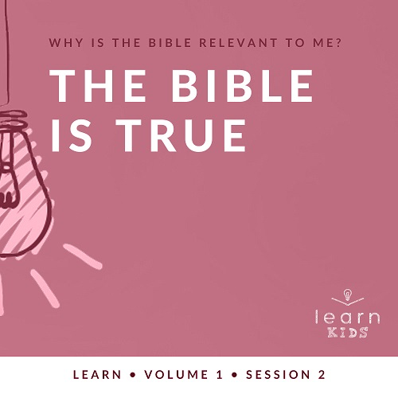

**Why is the Bible relevant to me?**

*Our upbringing often influences our view of the Bible. In your home, was the Bible a dust-covered book that you thought kept people from having any fun? Was it honored as the living, breathing Word of God? Or did your childhood view of God’s Word fall somewhere in between? In this* **Learn** *volume, we want kids to know that God speaks through His Word to those who will listen, giving guidance and correction for their lives (*[*2 Timothy 3:16–17*](https://ref.ly/logosref/Bible.2Ti3.16-17)*).*

**The Bible Is True**

*Throughout history the Bible has been proven to be true by archeology and other events. Although the books of the Bible were written by many people, they all speak to the truth of who God is. In our Bible story, Jesus reads a passage from the Old Testament that foretold information about Him. Based on what He read, Jesus announced that He was the One the passage was about. Although the people probably knew that passage well, most chose not to believe Jesus. We can learn from Jesus’ example and choose to believe and obey God’s Word.*

**Bible Lesson**

Jesus Proves the Scriptures Are True

[Luke 4:14–22](https://ref.ly/logosref/Bible.Lk4.14-22)

**Faith Fact**

I will obey God’s Word.

**Faith Verse**

[2 Timothy 3:16](https://ref.ly/logosref/Bible.2Ti3.16) (NLT)

All Scripture is inspired by God and is useful to teach us what is true.

**Preparing for the Session**

**Leader Preparation Time: 20–25 Minutes**

|  |
| --- |
| ***You Will Need***  ***Large Group***   * *Bible* * *Worship songs (Song suggestions: “Who You Say I Am” by Hillsong Worship; “Goodness of God” by Bethel Music; “Headlight” by Elevation Youth; “Breakthrough” by Elevation)* * *For groups not using a phone or tablet only, add:*   *• Projector or TV*  *• Laptop*  *•* ***Faith Fact Slide***  *•* ***Faith Verse Video*** *or* ***Slide***  *•* ***Bible Lesson Video***  *•* ***Teaching Time Video***  *•* ***Teaching Point Slides 1–3***  *• Bibles, one per kid (preferably all the same version)*  *• Black marker*  *• Pile of books*  *• File folder*  *• Seeds, one per kid*  ***Small Group***   * *Small prize or candy for each kid* * *Song: “Books of the Bible” by JumpStart3* * *Bibles, one per kid (preferably all the same version)* * *Ball* * ***Small Group Activity Page****, one per kid* * *Pencils, crayons, or markers*   *To download session videos, slides, and printables, visit:* [*BibleEngagementProject.com/downloads*](https://bibleengagementproject.com/Downloads) |
| ***Getting Ready***  ***Large Group***   * *Download videos and slides if needed.* * *Select worship song(s) and have them ready to play.* * *Use the black marker to label the folder “Evidence.”*   ***Small Group***   * *Print copies of the* ***Small Group Activity Page****, one per kid.*   ***First time leading* Learn *for Kids? Check out the*** [***Facilitator Guide***](https://0b769b0ed3569ef9d18b-f88d8272f61086866d50d048b43ef630.ssl.cf2.rackcdn.com/sites/biblengagementproject/Listen_Facilitator_Guide.pdf)***.*** |

**Large Group**

**30 Minutes**

*See what’s needed at the beginning of the session.*

**Introduction**

We’re back for another incredible time together. Who can remember what we’re focusing on in these sessions? *(Allow responses.)* Last time, we learned what the Bible is and why it matters to us. We learned that the Bible is God’s Word. People wrote the words, but God inspired them and told them what to write.

Today, we will learn that the Bible is true. I hope you already believe that. Why do you believe the Bible is true? *(Allow responses.)* Those are great answers. If you’re not convinced yet, we’re going to learn why we know the Bible is 100 percent true. We’ll unpack some of the evidence we have that proves the Bible is true.

**Faith Fact**

Because we know that the Bible is true, we must obey what it says. So our Faith Fact today says: **I will obey God’s Word**.

• *Show the* ***Faith Fact Slide.***

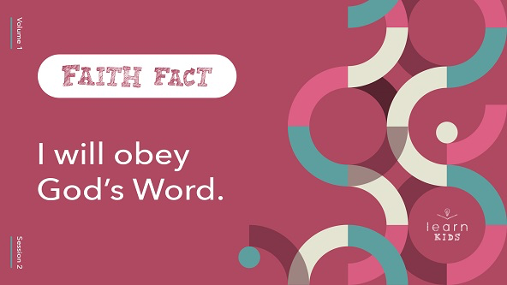

Let’s say it together three times as fast as we can! Ready? **I will obey God’s Word**.

• *Lead the kids in saying the Faith Fact three more times.*

**Game**

**Obey the Leader**

Obeying isn’t always easy. We’re instructed to obey God, His Word, our parents, and everyone in authority over us. That’s a lot of obeying! Do you obey all the time? *(Group response)*

We all make mistakes, but our intent should be to always obey. We’re going to practice obeying those in authority over us during today’s game. The leader is going to give instructions. Everyone must obey them if the leader says, “The leader says,” before the instruction. If the leader doesn’t say, “The leader says,” first, ignore the instruction. If you fail to obey the correct instructions, you’re out of the game.

• *Choose someone to be the leader.*

• *Have everyone stand up at their seats. If needed, have them spread out from each other and face the leader.*

• *Examples of instructions: jump five times, do three jumping jacks, high-five a friend, count to twenty as fast as you can, hop on one foot six times, etc.*

• *Watch the kids during the game to call them out as needed.*

• *Congratulate the winner.*

That was a fun way to practice obeying the leader. It’s a great way to remind us that God wants us to obey Him, too.

**Worship**

Let’s take some time to worship God today by singing and thanking Him for all He has done for us.

• *Lead the kids in singing one or two praise songs. See suggestions at the beginning of the session.*

**Bible Lesson**

|  |
| --- |
| ***You Will Need***   * *Bibles, one per kid (preferably all the same version)*   *No prep needed for this activity.* |

That was a great time of worship. Are you ready to learn more about why we believe the Bible is true? *(Group response)* Well, the first thing you’ll need is your Bible. I have my Bible. Now, let’s get ready to learn something new.

• *Hold up your Bible.*

Did you remember that the Bible is made up of more than one book? *(Group response)* How many books are in the Bible? *(Allow responses.)* There are sixty-six total. That’s a lot of books. Who’s read sixty-six books in your entire life? Raise your hand. *(Group response)*

There’s a lot packed into our Bible, but none of that even matters if we don’t believe it’s true. If the Bible is just a fictional book of made-up stories, why would we even take the time to read it? But if we know that it’s really God’s Word and filled with truth that can help us in our life, we should want to spend time studying it. Let’s pray and ask God to reveal a new truth to us from His Word.

**Prayer**

|  |
| --- |
| *Dear God, thank You for speaking the truth to us in Your Word. Help us to obey all Your instructions found in it. Amen.* |

**Video Intro**

Before we get started with the Bible story, let’s watch this video.

• *Play* ***Bible Lesson Video****.*

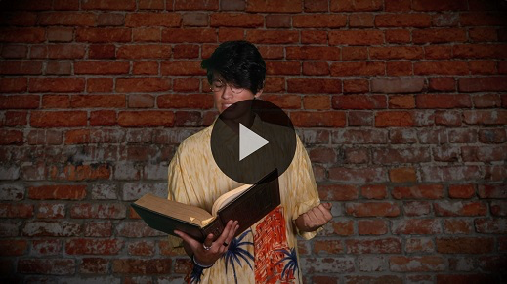

**Bible Story**

**Jesus Proves the Scriptures Are True**

Who’s lived in the same house for your entire life? Raise your hand. *(Group response)* Who’s moved around a lot? Raise your hand. *(Group response)* Jesus moved around when He was young. He was born in Bethlehem. He lived in Egypt for about three years, but He grew up in a place called Nazareth. As an adult, Jesus lived mainly in Capernaum, but He constantly traveled from town to town to do ministry.

In our Bible story today, Jesus returned to His hometown of Nazareth. He planned on teaching and doing ministry there, but the people in His hometown weren’t very receptive. Let’s see what Jesus said while He was in Nazareth that they might not have agreed with, but Jesus proved was true.

Grab your Bible or pull a Bible app up on your device. Open it to [Luke 4:14–22](https://ref.ly/logosref/Bible.Lk4.14-22).

• *Read* [*Luke 4:14–22*](https://ref.ly/logosref/Bible.Lk4.14-22)*aloud to the group.*

• *In order to keep Large Group time moving along, we don’t recommend having the kids read.*

• *Optional: Remind the kids to mark this place with their Bible bookmark (from Session 1) so they can read it on their own at home.*

**Teaching Time**

|  |
| --- |
| **You Will Need**   * Bible * Pile of books * Black marker * File folder   **Getting Ready**   * Use a black marker to label the folder “Evidence.” |

It’s pretty amazing that when Jesus, the Son of God, taught the people in His hometown, He was given the scroll of Isaiah to read—a book that has many prophecies about Him. Not only was Jesus fulfilling a super old prophecy, but also He was recognizing the writings of Isaiah as God’s Word. Jesus proved that the Scriptures were true. Many people still chose not to believe in Him. We know it’s important not only to believe God’s Word but also to obey it. Let’s say today’s Faith Fact together again. **I will obey God’s Word.** *(Group response)*

In today’s lesson, there are three things we need to know about God’s Word.

**1.** **Many writers shared God’s truth.**

• *Show the* ***Teaching Point 1 Slide.***

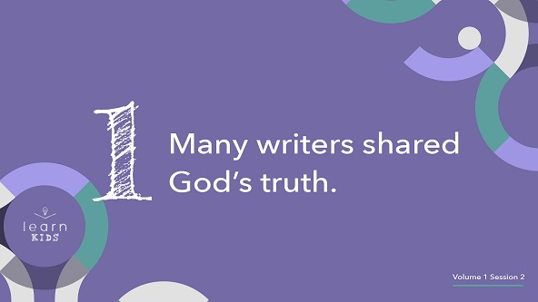

• *Pick up a pile of random books.*

Look at all these books. I like to read all kinds of books. How about you? *(Group response)* There are history books, storybooks, fantasy books, and comic books. All these books talk about different things, and they were all written by different people.

• *Show kids the different types of books as you name them (storybooks, history books, comic books, etc.).*

• *Hold up the Bible.*

Did you know the Bible is a unique book? In fact, it looks like one book, but it’s really one very long book that is made up of sixty-six smaller books. Those sixty-six books are different kinds of books, too. Some of them are full of rules and laws. Some tell the history of God’s people, the Israelites. Others are full of poems and wise sayings. Some are letters written to specific people or churches. Can you think of any other book like it? *(Allow responses.)*

I can’t think of any other book that even comes close to the Bible. Remember, last time we learned that the words in the Bible were written by people, but God inspired the words and gave them to the writers. The books found in the Bible may be very different from each other and written by different people, but they’re all filled with God’s truth. They point to who God is and what His plan is for His people. It’s not only for His people in Bible times, but also for us, too. That’s amazing!

Every one of those books was inspired by God to be written and placed in the Bible we read today. If you’re looking for something interesting to read, the Bible has what you are looking for.

**2.** **The Bible is proven to be true.**

• *Show the* ***Teaching Point 2 Slide.***

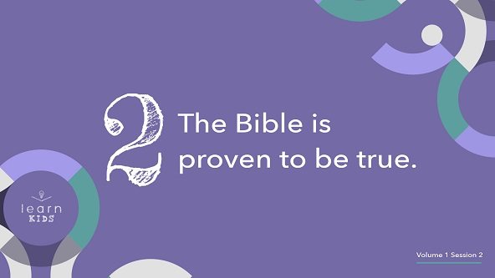

Believing the Bible is true requires an element of faith. For example, close your eyes right now.

• *Wait for all the kids to close their eyes.*

Can you see God? *(Group response)* Open your eyes.

• *Wait for all the kids to open their eyes.*

Can you see God now? *(Group response)* What about heaven? Can you see it? *(Group response)* Can you see any angels? *(Group response)*

We believe all these exist even though we can’t see, hear, or touch them right now. That’s the definition of faith. However, we don’t have to just blindly believe that the Bible is true and God is real. The Bible has been proven to be true by many sources.

There are people whose jobs focus on finding out what happened in the past. They are archaeologists, and they study the things they find when they dig up the ground. They discover what part of history those things came from. Over the years, we’ve learned about the places of the Bible from what they have found. Check out this video of some of the old places from the Bible in the city of Jerusalem.

• *Play* ***Teaching Time Video*** *in the background.*

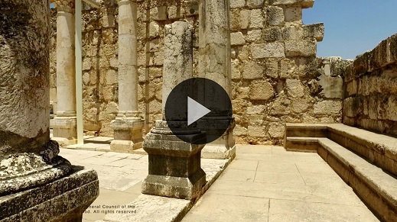

For example, archaeologists have found very old scrolls and writings of parts of the Bible. They’ve found evidence of some of the major events described in the Bible. There are many discoveries like this. It’s one of the reasons that prove we can trust the Bible. Jesus proved much of the Bible to be true when He fulfilled many prophecies through His life on earth.

We know Jesus taught people by using Old Testament Scripture passages, which proves that He believed those Scriptures were relevant and true. Other authors of ancient books also said that Jesus was real, not just the Bible. These books also tell about events that took place in the Bible.

**3.** **I will choose to believe and obey the Bible.**

• *Show the* ***Teaching Point 3 Slide.***

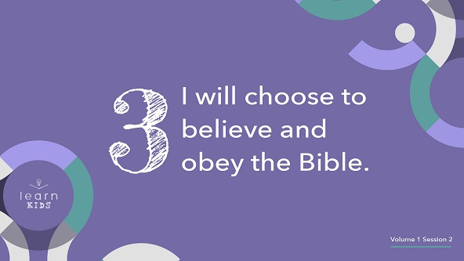

• *Hold up the folder labeled “Evidence” while you talk.*

I wish I could explain all the evidence that would help you know why we can trust God’s Word. Do you want to know a secret? *(Group response)* Even if I showed you all the evidence, you would still have to choose to believe that the Bible is true. That’s just like the people Jesus was talking to in our Bible story today.

We can’t go back in time and watch the Bible being written. We can’t watch David defeat Goliath or see Noah’s ark. Those are incredible stories that the Bible tells us about, but we can’t see for ourselves.

In the end, you must choose to believe that the Bible is true. You will never have all of the answers or evidence that every event in the Bible happened. You won’t be able to prove the Bible is true while you’re still on earth. That’s where the faith I was talking about earlier comes in. If you believe that God is real and you have chosen to follow Him, you must also choose to believe that God’s Word is true and choose to obey the instructions found in it.

**Prayer and Response**

*Consider playing a worship song softly in the background while kids pray.*

|  |
| --- |
| ***You Will Need***   * *Seeds, one per kid*   *No prep needed for this activity.* |

Let’s take a moment and respond to what we’ve learned today about God’s Word. Here is a seed.

• *Give every kid a seed to hold.*

When we look at our seed, it seems strange to believe that it will one day become a large plant. There is science and evidence to back that up. However, when we put a seed in the ground, we just have to trust that it will grow into the plant.

In the same way, we must trust that the Bible is God’s Word. If it is God’s Word, then we must choose to obey what it says. Sit quietly and look at your seed. Pray and ask God to help you trust His Word.

• *Give kids time to pray briefly.*

Now comes the more challenging part. Because you trust God’s Word, ask Him to show you how you need to obey the Bible more. Then, sit quietly and see if He speaks to you.

• *Give kids time to reflect and listen for the Holy Spirit to speak to them.*

• *Optional: Give kids an opportunity to share what they felt God said to them.*

**Prayer**

• *Optional: Have the kids repeat phrases of the prayer after you.*

|  |
| --- |
| Dear God, thank You for the Bible. We believe it is Your Word for us. We want to obey what You have said to us. Help us to do that now. Amen. |

**Faith Verse**

Our Faith Verse reminds us that God’s Word teaches us the truth. It’s found in [2 Timothy 3:16](https://ref.ly/logosref/Bible.2Ti3.16). Say it with me.

• *Play* ***Faith Verse Video****.*

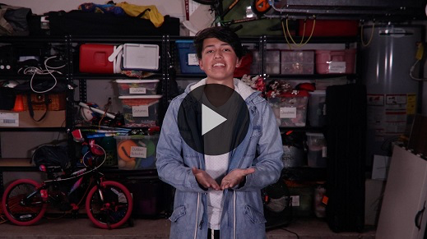

[2 Timothy 3:16](https://ref.ly/logosref/Bible.2Ti3.16) (NLT)

All Scripture is inspired by God and is useful to teach us what is true.

The truths we read about in the Bible will help guide the way we live our lives. If we obey God’s Word, we will stay on the right path. I want to do that. How about you? *(Group response)*

**Faith Fact**

Before we go to our small groups, let’s review our Faith Fact again.

• *Show the* ***Faith Fact Slide****.*



Shout it with me. **I will obey God’s Word.** I hope you learned something new about God’s Word today. Enjoy your Small Group time.

• *Dismiss kids to Small Group time or to go home if your group time ends here.*

**Small Group**

**30+ Minutes**

*This section can be done in conjunction with the large group or on its own if you do small groups with your kids. During Small Group time, the goal is to connect the kids with the Word of God and to each other. All activities are led by the small group leader.*

**Group Connection**

**Take a Risk**

|  |
| --- |
| ***You Will Need***   * *Small prize or candy for each kid*   *No prep needed for this activity.* |

Are you ready for a challenge? *(Group response)* You’ll have to take a little risk and be ready to obey any instruction I give if you want to win a prize. Who wants to go first in our obedience challenge? *(Group response)*

• *Give each volunteer one of the following challenges:*

• *Do your favorite move.*

• *Share one thing that is true about you that most people wouldn’t know.*

• *Sing a line from your favorite song.*

• *Say your favorite verse in the Bible from memory.*

• *Come up with a challenge for someone else in the group to do.*

• *Make the craziest face you can.*

• *Show everyone a body trick you can do.*

• *Try to do a handstand.*

• *Make up a simple handshake with someone in the group.*

• *Share today’s Faith Fact or Faith Verse with the group.*

• *Come up with a challenge for the leader to do.*

• *If they choose to take the challenge and complete it, give them a small prize or candy.*

• *Keep playing until everyone who wants to play has had a chance to take a challenge.*

That was great! You were very brave to do these challenges.

**Learn about It**

|  |
| --- |
| ***You Will Need***   * *Bibles, one per kid (preferably the same version)* * *Song: “Books of the Bible” by JumpStart3*   *No prep needed for this activity.* |

**Scripture Search:** [**2 Timothy 3:14–15**](https://ref.ly/logosref/Bible.2Ti3.14-15)**;** [**2 Timothy 3:16–17**](https://ref.ly/logosref/Bible.2Ti3.16-17)**;** [**Psalm 33:4**](https://ref.ly/logosref/Bible.Ps33.4)**;** [**Proverbs 30:5–6**](https://ref.ly/logosref/Bible.Pr30.5-6)

Let’s dig deeper into God’s Word and see what else He has to say about the Bible. As we find and read each of these verses, let’s consider:

How does this Scripture teach us about what God wants us to know about trusting His Word?

What does it mean for our life today?

• *Give each kid a Bible and search for one or more of the Scriptures as a group as time allows. When everyone has found the Scripture, have one of the kids read it. Then, answer the questions about it.*

• *Pair kids who need additional help with older kids or start simple and look up the session’s Bible story Scriptures:* [*Luke 4:14–22*](https://ref.ly/logosref/Bible.Lk4.14-22)*. Kids will get better at finding Scriptures the more they practice.*

• *Optional: Make this a competition to see who can find the Scripture first.*

**Bible Reading Tip**

Whenever we read the Bible, it’s important that we ask this question: Because this is true, what should I do? We should be looking for ways to make sure we’re obeying what God says in His Word. If you aren’t sure about something it asks you to do, then you can always ask an adult about it or look for other Bible verses that tell you to do a similar thing.

**Challenge**

Choose a passage of the Bible to read this week that you haven’t read before or aren’t familiar with. Write down some of the things the passage tells you to do on a piece of paper. Show it to your parents or bring it to Small Group next time.

**“Books of the Bible” Song**

While we’re learning about God’s Word, let’s learn all the books in God’s Word, too. Let’s sing the “Books of the Bible” song.

• *Play the “Books of the Bible” song.*

**Faith Fact**

All of our talking about the Bible reminds me of our Faith Fact. Say it with me: **I will obey God’s Word.**

**Group Discussion**

*Feel free to use all or just a few questions as a jumping-off place for good discussion. Questions marked with * are designed for more conversation. Adjust the questions based on the age or maturity of your group. Typically, older kids will be able to dive a little deeper than younger ones.*

**Questions**

• *If small group activities are not immediately following Large Group time, you may want to read the Bible story passage before this discussion.*

How many books are there in the Bible?

About how many authors wrote the books that are included in the Bible?

* How many books of the Bible can we name? Try not to repeat any of the books that have already been mentioned.

* In our Bible story, how did Jesus prove the Bible is true? What other ways do you think Jesus proves that the Bible is true?

Do sources other than the Bible prove that it is true?

* Why do you believe that the Bible is true?

* Are there any instructions in the Bible that are hard for you to follow? Why?

* How can we work on obeying God’s Word?

* Have you ever disobeyed something in God’s Word? Share about it with the group, if you’re willing.

**Prayer Requests**

*Finish group discussion by sharing prayer requests and praise reports. Keep track of your small group’s prayer requests and review them each time you meet.*

**Prayer**

*Have kids pray for each other’s prayer requests.*

**Faith Verse Review**

|  |
| --- |
| ***You Will Need***   * *Ball, one per group*   *No prep needed for this activity.* |

Our Faith Verse is [2 Timothy 3:16](https://ref.ly/logosref/Bible.2Ti3.16). It tells us that we can learn the truth by reading God’s Word. Let’s say it together.

• *Show* ***Faith Verse Video****.*



[2 Timothy 3:16](https://ref.ly/logosref/Bible.2Ti3.16) (NLT)

All Scripture is inspired by God and is useful to teach us what is true.

**Faith Verse Fun**

**Verse Pass**

Everyone will need to do their small part in saying the Faith Verse. We’re going to pass a ball. When you catch the ball, you have to say just one word of the Faith Verse. If you don’t know the next word in the verse, the group can help you. Do you think we can work together as a group to say the Faith Verse? *(Group response)* Let’s see how it goes.

• *Have the group sit down or stand up in a circle with some distance between each kid.*

• *The person holding the ball will say the first word of the Faith Verse and pass the ball to the next kid in the group until the Faith Verse is completed.*

• *Play a few rounds encouraging the kids to try to get faster each time.*

• *Challenge option: Toss or roll the ball to any kid in the group to say the next word in the verse.*

• *Remember to help out kids if they don’t know the verse yet.*

**Activity Page**

**Design a Bible Cover**

|  |
| --- |
| ***You Will Need***   * ***Small Group Activity Page****, one per kid* * *Pencils, crayons, or markers*   ***Getting Ready***   * *Print copies of the* ***Small Group Activity Page****, one per kid.* |

When we believe that God’s Word is full of truth, we should want everyone we know to read the Bible. Did you know that the people who print Bibles sometimes give them very creative covers? *(Group response)*

• *Look at the covers of Bibles kids brought with them.*

Today, you’re going to design a creative Bible cover. Decorate it however you’d like.

• *Give each kid a copy of the* ***Small Group Activity Page*** *and pencils, crayons, or markers. (Some kids like to sketch a design in pencil first.)*

• *Optional: Practice the “Books of the Bible” song as they work on their design.*

**Dismissal**

I enjoyed learning with you how we can know God’s Word is true. Let’s close in prayer.

**Prayer**

|  |
| --- |
| *Dear God, thank You for teaching us the truth through Your Word. Help us to obey all the instructions found in it. Amen.* |

**Faith Fact Recap**

• *Show the* ***Faith Fact Slide****.*



One important thing I want you to remember from today is our Faith Fact. Say it with me: **I will obey God’s Word.** I’m so glad you came today. See you next time.

• *Send home the* ***Small Group Activity Page*** *and the seed (if kids still have it).*

• *Remind parents that there are* ***Family Devotions*** *available on the app to do with their kid.*

• *Tell everyone the date and time for the next session.*